ABOUT DR. JUDITH WRIGHT
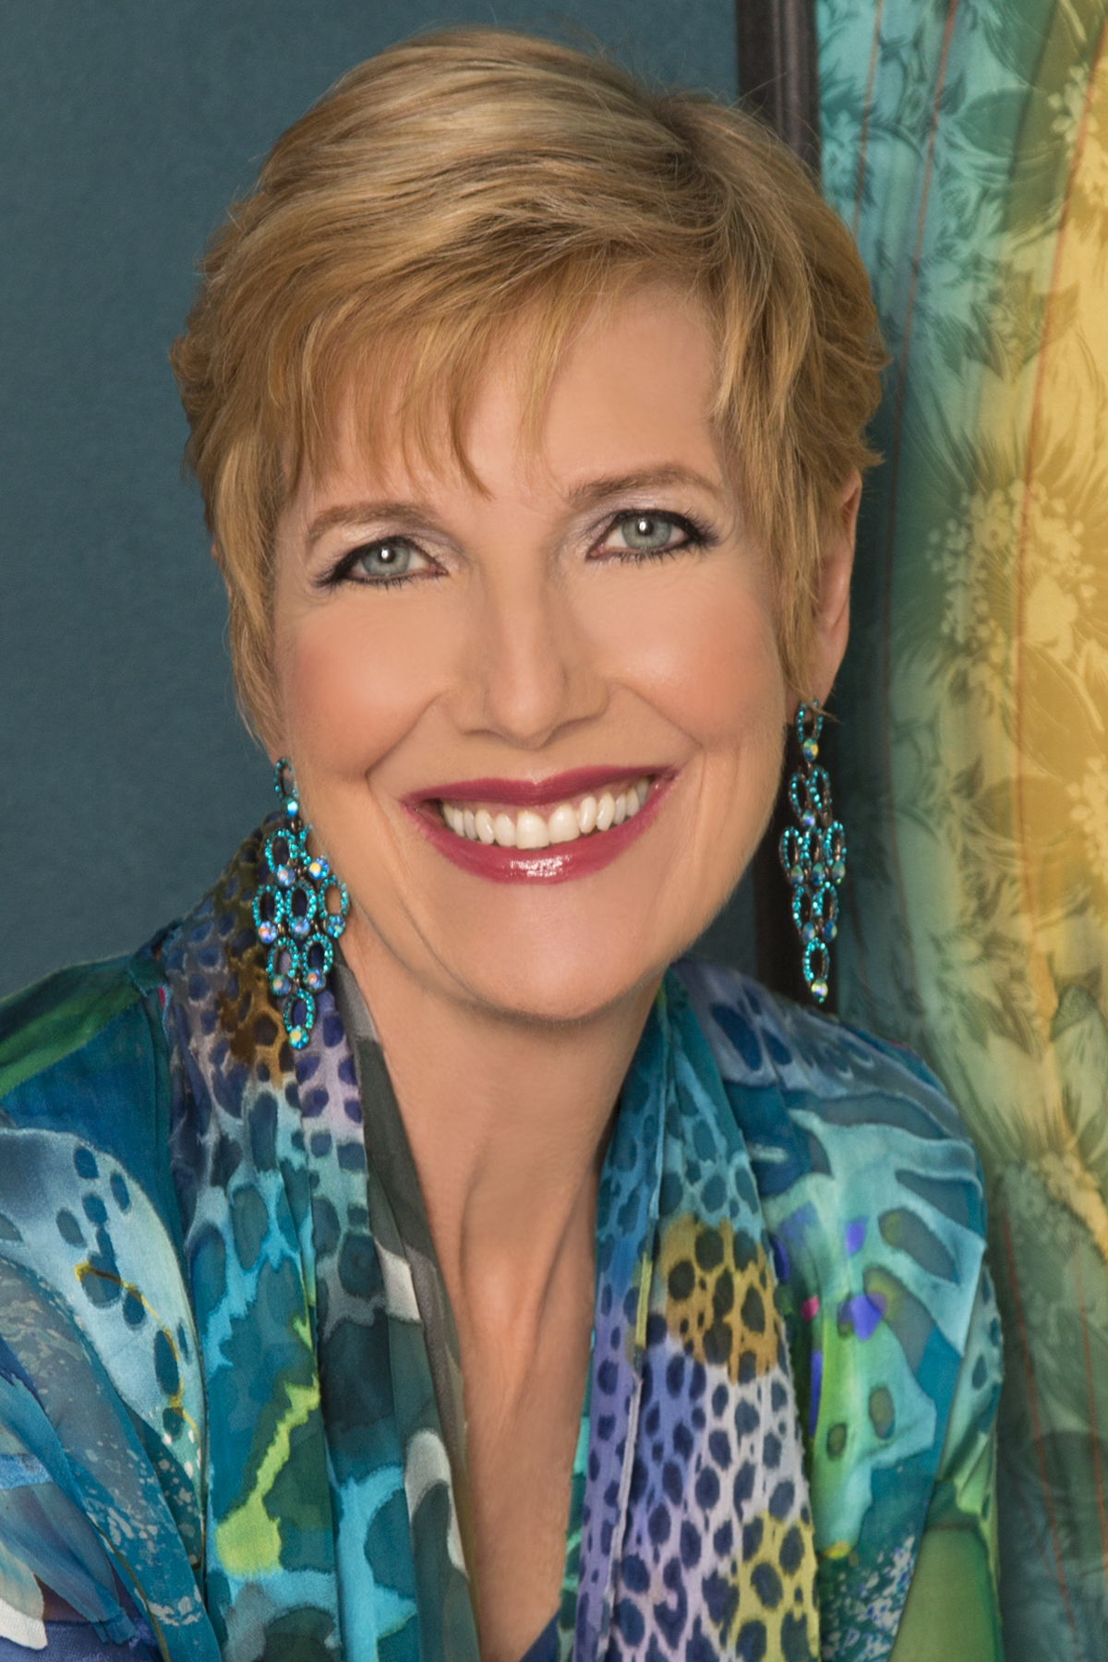
A media favorite, sought‐after speaker, respected leader, bestselling author, world‐class, coach, and corporate consultant, Dr. Judith Wright (www.judithwright.com) is Professor of Transformational Coaching at the Wright Graduate University for the Realization of Human Potential and president of the Wright Foundation, a 501(c)(3) non profit dedicated to helping individuals bring out their best personally and professionally. Dr. Wright wrote There Must Be More Than This, The One Decision, The Soft Addiction Solution, and the award-winning Transformed:The Science of Spectacular Living to share her proven personal transformation methodologies with a broader audience. Her newest book, The Heart of the Fight, was just released in February 2016.

Judith has appeared as a featured lifestyle expert and coach on ABC’s 20/20, Oprah, Good Morning America, the Today show and hundreds of radio and television shows. Called the “world’s ultimate expert,” her work has appeared in over 80 magazines and newspapers around the globe including Marie Claire, Fitness Magazine, Health, Better Homes and Gardens, Shape, The New York Daily News, The Boston Herald, and The San Francisco Chronicle. Judith has the rare ability to touch groups of all types and sizes, communicating her messages with great passion that inspires audiences.

A pioneer in the field of human development, Dr. Wright first rose to national prominence by developing innovative education and early childhood development programs for those with developmental disabilities. These experiences fueled her passion for developing human potential and strengthened her deep‐rooted commitment to help people live great lives. Dr. Wright then applied the profound insights she discovered to the general population, spurring people from all walks of life to significant success in personal transformation, leadership development, and personal goal fulfillment.

After twenty years of developing inspirational personal development programs, she co‐founded Wright — a cutting edge coaching and training organization in Chicago — and the Wright Graduate University for the Realization of Human Potential, offering graduate certificates, masters and doctoral degrees in transformational leadership, transformation coaching, social intelligence, and emotional intelligence.

Dr. Judith Wright is the founder of SOFIA (Society of Femininity in Action), providing revolutionary leadership training for women. She is a sought‐after speaker and expert in areas like leadership, women’s training and development, relationships, wellness and lifestyle, career fulfillment, spirituality, and more. She has been a keynote speaker for many events, conferences, and corporations including AC Nielsen, Chase (formerly Bank One), Kellogg’s, Miss USA Women’s Power Summit, Association of Junior Leagues International, NAWBO, Abbott, Hispanic Alliance for Career Enhancement (HACE), Meeting Planners International (MPI), University of Chicago, Rotary Club of Chicago, Society of Women Engineers, and many more.

Dr. Wright is also one of the country’s foremost experts on transformational leadership founding the Transformational Leadership Symposium, convening experts from around the nation to recognize cutting edge transformational leaders including Brad Anderson, former CEO of Best Buy, as well as the 2011 award recipient, Dr. Muhammad Yunus.

Dr. Wright has her BA in psychology, her MA in education and counseling and her doctorate in Educational Leadership and Change.

